Classes and Objects

1. Java is a programming language ___
   1. Functional
   2. Object Oriented
   3. Theoretical
   4. All previous
2. In the Java programming language, code is placed inside ___
   1. Classes, Interfaces
   2. methods
   3. blocks
   4. All previous
3. Properties are implemented using ___ in Java.
   1. methods
   2. interfaces
   3. All previous
   4. variables
4. A Class in Java is like a ____.
   1. Prototype
   2. instruction sheet
   3. Flat
   4. All previous
5. What is the file extension used for a public Java class source code?
   1. .j
   2. .class
   3. .Java
   4. Neither
6. Below is the list of three characteristics of an Object EXCEPT ONE. Which?
   1. Behaviour
   2. Condition
   3. Attribute
   4. Identity
7. A keyword used to initialize an object.
   1. NEW
   2. old
   3. CLONE
   4. METHOD
8. What does this mean?

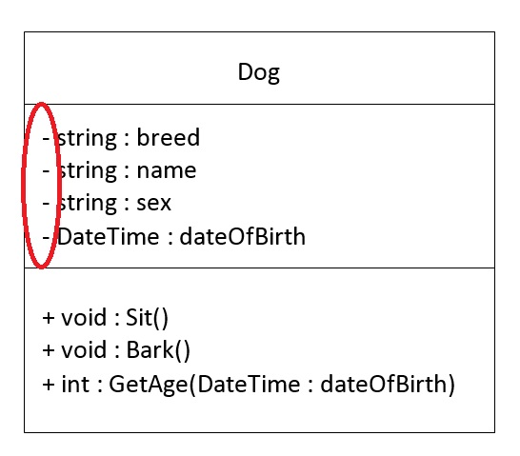

* 1. packages
  2. Protected
  3. Public
  4. Private

1. What does this mean?

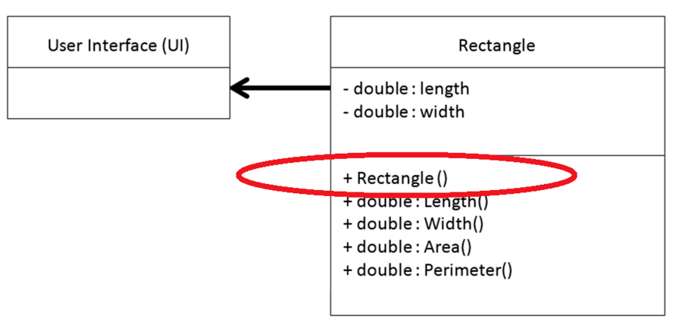

* 1. Field
  2. Variable
  3. Builder

1. An object is a _________ of a class.
   1. Inheritance
   2. Iteration
   3. Instance
2. Predict the result of the following Java program?

|  |
| --- |
| classTest {  int i ;  }  classMain {  public static void main( String args []) {  Test t = new Test( 1);  System.out.println ( ti );  } |

* 1. 0
  2. junk value
  3. compiler error
  4. runtime error

1. Java uses threads to allow the entire environment to be ______.
   1. Symmetrical
   2. Asymmetric
   3. Synchronous
   4. Asynchronous
2. What is the result of the following Java code?

|  |
| --- |
| **class First**  {    voiddisplay ( )  {  System.out.println ("Inside First");  }  }  **class Second extends First**  {    voiddisplay ( )  {  System.out.println("Inside Second");  }  }  **class Test**  {  public static void main(String[] args)  {  First obj1 = new First();  Second obj2 = new Second();  First ref;  ref = obj1;  ref.display();    ref = obj2;  ref.display();  }  } |

1. compilation error
2. Inside First

Inside second

1. Inside First

Inside First

1. runtime error
2. In Java, when we implement an interface method, it must be declared as:
   1. Private
   2. Protected
   3. Public
   4. insurance